4. SYSTEM ANALYSIS AND CLASSIFICATION
Experiment 4.1 - Discrete -Time System
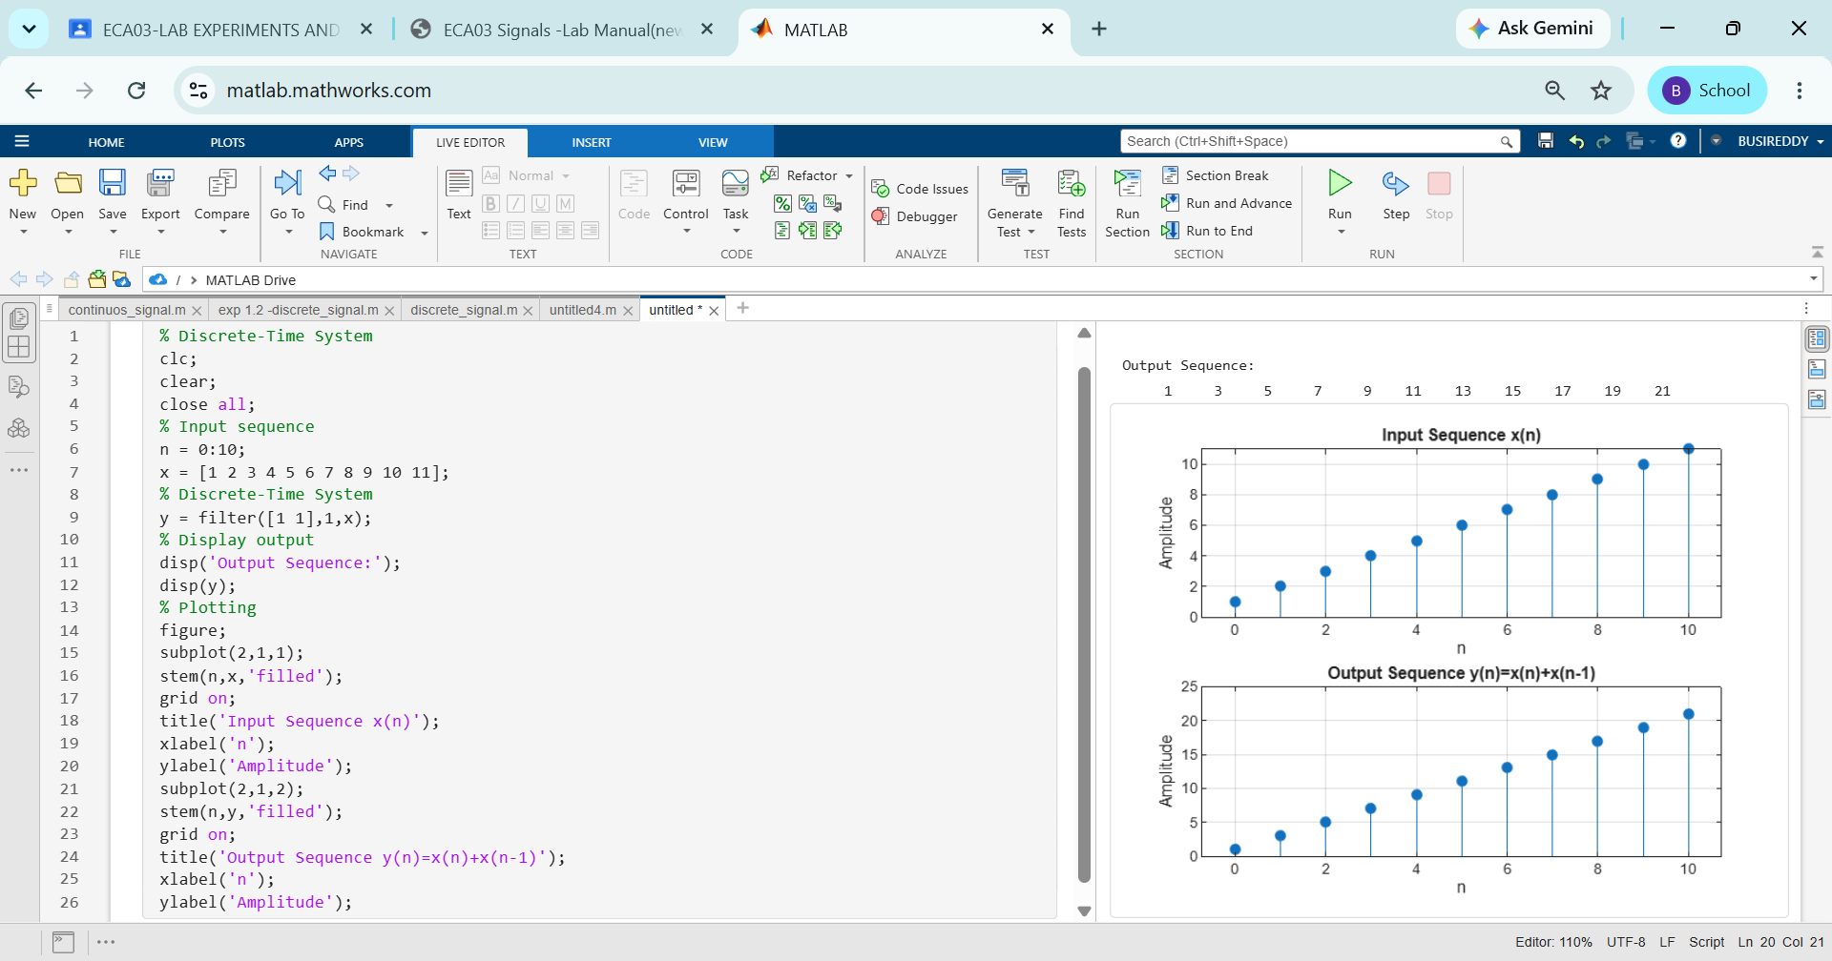
Experiment 4.2 Causal/Non-Causal System
